Boelens python symposium (IHS)
Schedule: June 17th 2020
9:00 am -9:15am Opening Remarks: Ari Flagle

9:15am- 9:45am Keith Mcpeek : Boelen’s pythons captivity and thinking outside the box

9:45am – 10:30am Laurence Ketchington: Naturalistic enclosure designs and the success in captivity with the genus Simalia. Ireland

10:30am- 11:15am Quetzal Dwyer: Simalia boeleni Successful reproduction in Costa Rica

Lunch 11:15am-12:30pm

12:30pm – 1:15pm Nicholas Hussard: Raising Simalia boeleni in France with special focus on Neonate care.

1:15pm -2:00pm Ari Flagle : Simalia boeleni wild nesting ecology

2:00pm-2:45pm Merryelli Rodriguez: Health and Quarantine for new viruses with special emphasis on S.boeleni

2:45 -3:30pm Warren booth: Python phylogenetics, and impacts of small genetic populations
Small break
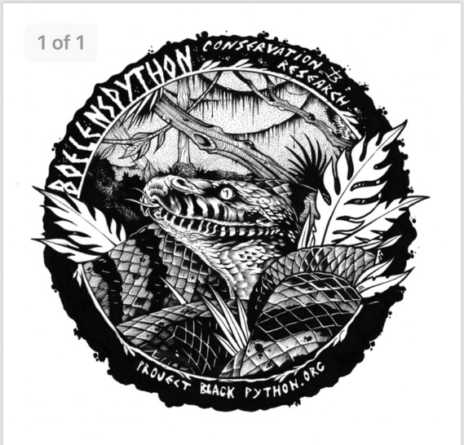
Open panel discussion 4:00 – TBD

